IMPLEMENTING THE PROGRAM FOR THE TIME SERIES DATA CLEANING AND PREPROCESSING TECHNIQUES

AIM :

To implement the program for the Time Series Data Cleaning And Preprocessing Techniques.

Procedure and Code :

Step 1 - Import the Files and Libraries .

**import pandas as pd**

**import matplotlib.pyplot as plt**

**import seaborn as sns**

Step 2 - Describe and Read the Data

**df=pd.read_csv('/content/drive/MyDrive/TimeSereisDatasets/**

**daily-website-vvisitors.csv)**

**df.head(10)**

Row Day Day.Of.Week Date Page.Loads Unique.Visits First.Time.Visits Returning.Visits

0 1 Sunday 1 9/14/2014 2,146 1,582 1,430 152

1 2 Monday 2 9/15/2014 3,621 2,528 2,297 231

2 3 Tuesday 3 9/16/2014 3,698 2,630 2,352 278

3 4 Wednesday 4 9/17/2014 3,667 2,614 2,327 287

4 5 Thursday 5 9/18/2014 3,316 2,366 2,130 236

5 6 Friday 6 9/19/2014 2,815 1,863 1,622 241

6 7 Saturday 7 9/20/2014 1,658 1,118 985 133

7 8 Sunday 1 9/21/2014 2,288 1,656 1,481 175

8 9 Monday 2 9/22/2014 3,638 2,586 2,312 274

9 10 Tuesday 3 9/23/2014 4,462 3,257 2,989 268

**df.shape**

(2167, 8)

**df.describe(include='all').T**

**df.info()**

**<class 'pandas.core.frame.DataFrame'>**

**RangeIndex: 2167 entries, 0 to 2166**

**Data columns (total 8 columns):**

**# Column Non-Null Count Dtype**

**--- ------ -------------- -----**

**0 Row 2167 non-null int64**

**1 Day 2167 non-null object**

**2 Day.Of.Week 2167 non-null int64**

**3 Date 2167 non-null object**

**4 Page.Loads 2167 non-null object**

**5 Unique.Visits 2167 non-null object**

**6 First.Time.Visits 2167 non-null object**

**7 Returning.Visits 2167 non-null object**

**dtypes: int64(2), object(6)**

**memory usage: 135.6+ KB**

Step 3 - Cleaning and preprocessing the data

**data_null = df.notnull().sum**

**df['Page.Loads'] = df['Page.Loads'].str.replace(',', '').astype(int)**

**daywise_data = df.groupby('Day')['Page.Loads'].sum()**

Step 4 - Dropping the duplicate and missing values

**data = df.drop_duplicates()**

**print(f"Dataset now has {data.shape[0]} rows and {data.shape[1]} columns.")**

Step 5 - visualizing the Dataset

**daywise_data.plot(kind='bar', figsize=(8, 5), color='purple')**

**plt.title('Page Loads by Day of the Week')**

**plt.xlabel('Day of the Week')**

**plt.ylabel('Page Loads')**

**plt.xticks(rotation=45)**

**plt.show()**

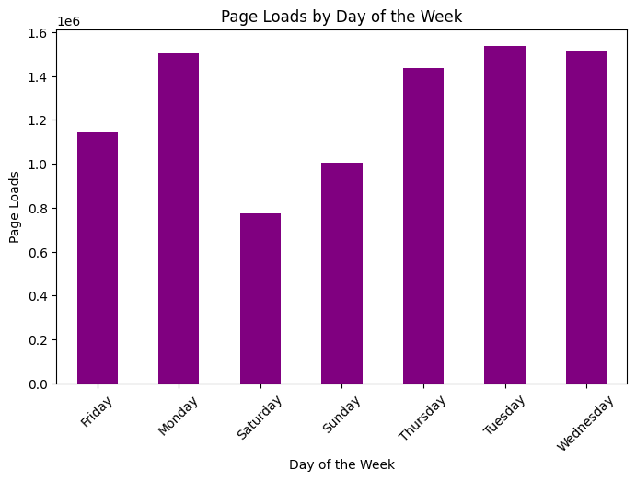

**Result:**

Thus the Program has been Executed Successfully.